Ionic-Composite Lodge and Jack Benny
A story of three people

Ronald Koretz, P.M.

David Markowitz was a successful scrap metal dealer from Romania who immigrated to the northwestern United States (also living in Vancouver, BC) around the turn of the 20th Century. He had a son (Hilliard) and a daughter (Sadie) and subsequently moved his family to southern California. Around 1910, he changed his family name to Marks. He joined Composite Lodge #639 within a decade or so after it was formed. Al Gordon was born in 1923 and grew up in New York City. After serving in World War II, he moved to Los Angeles and subsequently joined Ionic Lodge #570.

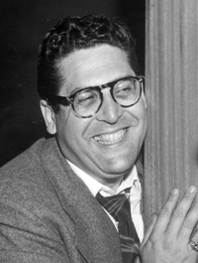
Hilliard joined Composite Lodge when he grew up. He worked as a producer of radio and television programs.

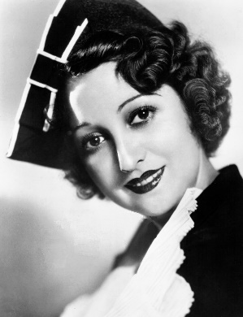
Sadie went into show business and changed her name to Mary Livingstone.

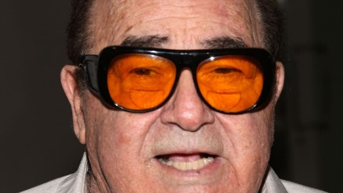
Al was a writer and moved to California because he was offered work in Hollywood, initially with Eddie Cantor.
What is the common link between these three people?

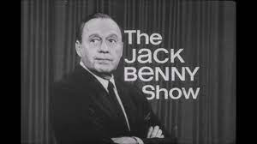

Mary Livingstone married Jack Benny and was his costar for many years.
Hilliard Marks produced Jack Benny’s shows on radio and television for virtually the entire time.
Al Gordon, teamed with Hal Goldman, wrote for Jack Benny until his death in 1974.

